Water Jug Problem

AIM: To write a Python program to solve the Water Jug Problem using state-space search.

Algorithm:
- Start the program.
- Initialize the capacities of the two jugs and the target quantity.
- Represent the current state using the water quantities in both jugs.
- Generate possible actions: fill a jug, empty a jug, or pour water from one jug into the other.
- Apply the actions to generate new states.
- Continue searching until the target quantity is obtained.
- Display the sequence of states leading to the solution.
- Stop the program.

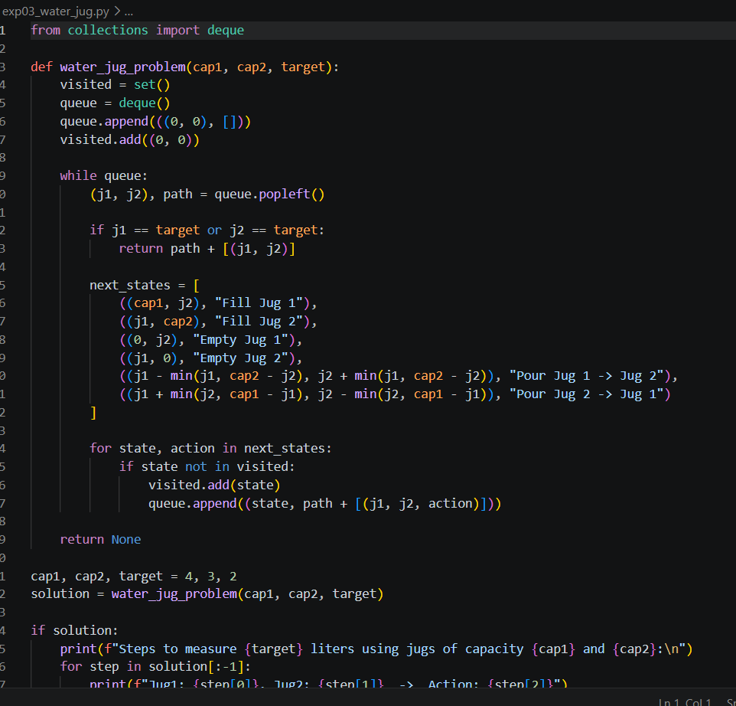
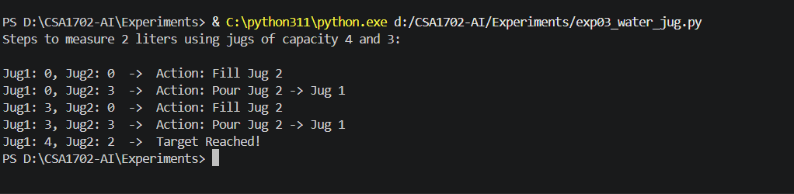
Code :
Output :
Result :
Thus, the Python program to solve the Water Jug Problem was executed successfully.

